[https://www.wisestamp.com/blog/formal-email-writing-formats/](https://www.wisestamp.com/blog/formal-email-writing-formats/" \o "https://www.wisestamp.com/blog/formal-email-writing-formats/" \t "_blank)

**The basic elements of professional email writing:**

Your email address

Subject line

Email opening

Email body

Email ending

Email Sign off

---------------------------------------------------------------------------------------------------------------------

**Email subject line guidelines:**

Be clear and specific – avoid using generic or clickbait subject lines that say nothing or make unrealistic promises, like “find out how to double your business in a week”.

Be original – avoid using those all too common subject line templates you find on the internet. Instead make original subject lines that are relevant, personal, and concise.

Add relevancy – address something that the recipient will recognize, like an acquaintance name or a an article/ show/ book they appeared on.

**1)** You are an intern in ABC Consulting Pvt. Ltd. Write an email to your manager Mr. Ramesh, updating him about your work progress and challenges you are facing.

=> **Update about work progress and request to help with challenges faced**

**latest work progress report and request your help on challenges faced**

**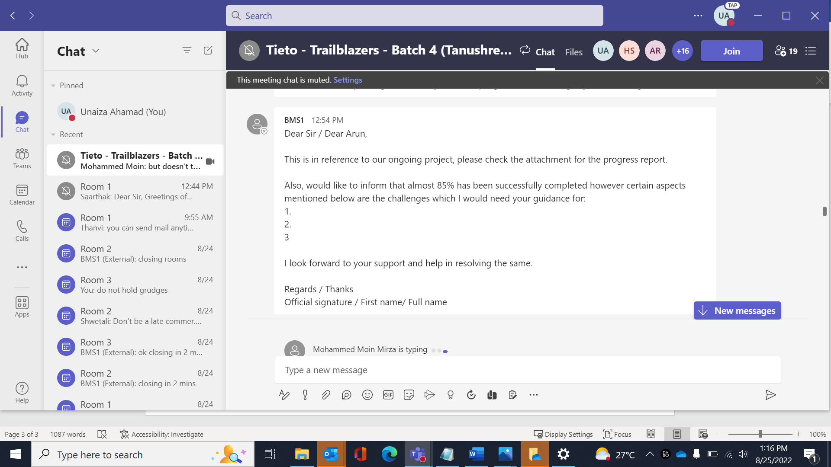**

**2)** You are Mr. Naman and you recently bought a laptop from Smart Appliance Company. Write an email to Mr. Arun, the manager of Smart Appliance Company, explaining the poor quality of service offered to you in the city.

=> **Complaint regarding the poor quality of service received**

**unsatisfactory services---**

**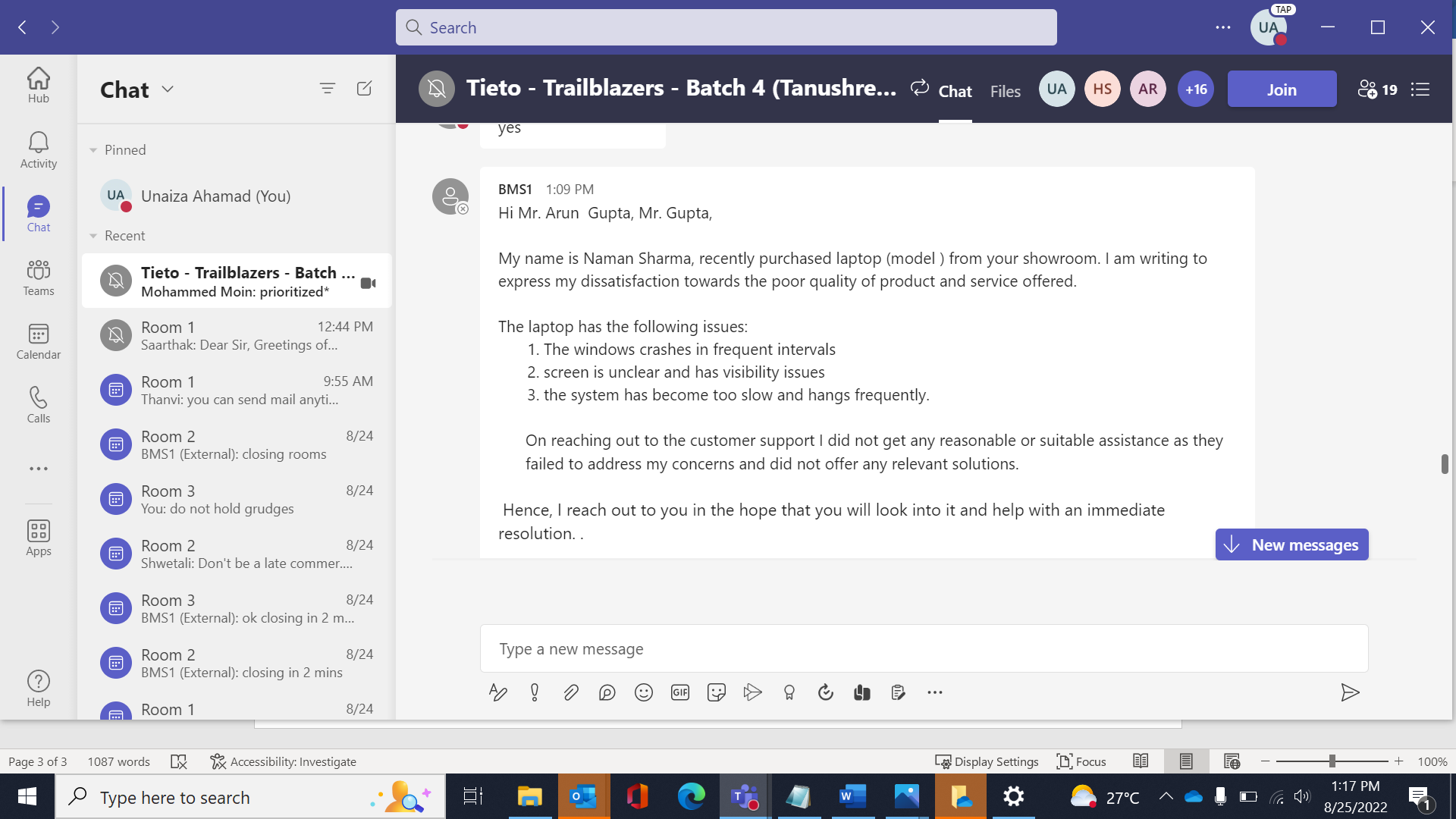**

**3)**You are Ron, working in an organization as project head. There is a meeting scheduled for August 03 with the client leader. Suddenly you realize that your team is totally packed on 3rd Aug and none of your team members would be able to attend the meeting that day. You need to reschedule the meeting. Being little busy, write an email to the client explaining the situation and apologizing for the late update.

=> **Important! Request to reschedule meet on <date>**

**4)**You are john and the project you worked on was successful. There is a success party arranged regarding the same. Write an email to your client inviting to the party.

=> Subject: **Invitation for Project Success Party**

****

**5)** You are Henry and you are leading a team. Write an email to the HR team requesting to facilitate a short training session on few essential skills to your team.

=> Sub: **Request to facilitate a short training session on few essential skills to our team required for our upcoming project**

****

**6)** You are John, living in a local residential society. Write an email addressing the inspector of local police station, Mr. Gupta, complaining about the mischievous bikers creating nuisance with their rash bike riding every evening outside your society.

=> Subject : **Complaint regarding nuisance caused by bikers in residential society**

**7)**You are the Executive Manager at Vodafone and you recently got a complaint from a loyal customer about his SIM card not working. Write an email apologizing for the issue and providing him a solution within 2 days.

=> **Apology for the issue faced and we'll promise to give the solution within 2 days**

8)You are Ali, a new joinee with a mobile manufacturing company. Your Company is rolling out a new training program with latest technology and you want to participate in it. Write an email to your boss expressing your desire to enroll in the program and how it will further your career and benefit the company.

=> **Request to enroll/participate in the upcoming training program**

8)You are manager of a department. There is a new floor manager joining your team soon. Write an email to your staff informing them about the new joining manager and his experience.

=> **Welcome to the team his name**

**Please Welcome Mr. ABC who joined our department as the Floor manager toady**

9)You are an architect working directly with a client. Write an email to the client that you are sending some plans and asking him to review and suggest changes if needed.

=> **Request to review above plans regarding our current project**

**Request to review the plan and suggest changes if required**

10)You are Prashant and you are a team lead. Your team failed to deliver a project in time as the team is affected with Cholera. Write an email to the client explaining him about the testing team's situation and apologizing for the delay in project delivery

=> **Apology for delayed project delivery due to some unfortunate situation within the team.**

11)You are a project manager and you took the help of Billy, an additional resource, to complete the task in time. Write a "Thank You" email to Billy appreciating his timely help including the below phrases in the email.

=> **Appreciate your help and guidance towards timely completion of the project**

12)You are an employee of XYZ technology Ltd. Write an e-mail to your manager asking for an emergency sick leave for

2-3 days as you are suffering from dengue, and the doctor has advised for bed rest.

=> **Request for emergency sick leave for 2-3 days**

13)You are Asma, team lead of your team write a mail to the facilities team regarding the lagging issues faced by the

system number S-11 and ask them to get it fixed as soon as possible.

=> **Requesting to fix the lagging issues faced by system S-11 at the earliest**

**Request to fix the lagging issues faced by system S-11 as early as possible**

14)Write an email to your colleague congratulating him for getting promoted to the upper level. And also ask him to

give you some knowledge about the same so that you can work on your skills and get promoted.

=> **Congratulation's on your Promotion.**

15)Write a mail to your landlord stating the problems that you're facing in the interior of your flat. And ask him to get it repaired as soon as possible because your parents are going to visit you soon.

**=> Request to repair the interiors of the flat at the earliest**

**Requesting you to fix the interior of the flat at the earliest**

-------------------------------------------------------------------------------------------------------------------------

**EMAIL BODY**

Formal - Unknown - very senior person (official)

Semi Formal - immediate manager / Colleague / landlord / professor

Informal - Family and Friends - personal

**Formal:** (CEO, Client, don't know in official context)

1. Salutation - Dear Sir/ Dear Mr. Full Name/ Mr. Last Name.

2. Intro and purpose of writing

3. Points mentioned in the question

4. Closing line - stating what you need/ expect

5. Sign off - Regards, your full name

**Semi formal:**

1. Salutation - Dear Sir/ Dear / Hi First Name.

2. Purpose of writing

3. Points mentioned in the question

4. Closing line - stating what you need/ expect

5. Sign off - Regards, your full name

---------------------------------------------------------------------------------------------------------------------------------------**A team member has been late regularly for work and your project is getting hampered due to the same. Despite several discussions this has not changed. Write to him formally stating the actions needed and challenges faced.**

**Manager:**

Subject: Regarding being regularly late to office.

Hi <name>,

We have noticed that you have been late regularly the last two weeks/ time frame and we are concerned about your well being. We feel that there is a reason that you have not been performing as earlier and would like to be of assistance in any way possible.

Please understand, that delays from you is affecting the whole team and our performances are also at stake.

hence we look forward to you sharing your grievances with us and look forward to be able to support you in any possible way.

Thanks,

Xxx

**Employee:**

Subject : Apology for being late to the office.

Dear Team,

Sorry for the inconvenience caused due to me being late to the office.

As my mother has been admitted to the hospital and me being the single child have to look after her, I am not able to reach office on time. She has almost recovered from it, so as soon as she recovers totally I will be on time to the office, I also assure you that I will complete all the pending work load. Henceforth, I will meet the deadlines.

Regards,

John Michael.

and i also apologise for not being able to share my situation earlier.

My mother is severely ill and hospitalized due to ---- aliment

----------------------------------------------------------------------------------------------------------------------

**Your Client is asking to modify certain features in the program at the very last minute of completion of the project. These changes could impact the program and also alter the time lines and budget. inform the same.**

**Client:**

sub: Request to modify the user input section of the program

Dear John,

This is in reference to the discussion we had about the program yesterday.  
I would like some modifications in the user input section. The changes required are as follows:  
1)Add more input fields.  
2)Clean separation of the design layer.  
Kindly implement the required changes.

Look forward to the product delivery at the earliest with the latest modifications.

Regards,  
Naman

**Employee:**

Subject: Regarding the modification of user input section of the program

Dear ---

with reference to your mail, I would like to bring to your attention that the changes suggested by you are certainly workable with some discussions and variations in the current process.

IF POSSIBLE : However, I would also highlight that these changes at the last minute could affect the project and also alter the budget and delivery timelines. hence would like to suggest that we go with the inital plan or if you feel these changes to be must in the plan do await for the revised budget and timeline contract. Or IF NOT POSSIBLE: however, these alteration will bring a lot of complexities and the variation can disrupt the whole project which is at the final stage. Thus would like to request to continue with the original plan and not initiate these alterations.

Look forward to your confirmation on the continuity of the program as planned initially.

---------------------------------------------------------------------------------------------------------------------------

**Your colleague has been on the phone daily talking loudly and constantly and this is hampering your work and also disturbing the environment. convey him the same**

Sub : Inconvenience caused due to usage of cell phone in the work environment.

Dear ABC,

**Subject: Regarding being regularly late to office.**

Hi <name>,

We have noticed that you have been on the phone daily talking loudly and constantly during the office hours.Since this has been hampering the peaceful working atmosphere in our workplace, I understand that you have your own personal reasons to do so. but the co-workers find it difficult to cope with their works.

I think you will take these words into consideration and speak softly. It will be very helpful .

Thanks,

xxx

----------------------------------------------------------------------------------------------------------------------------

Dealing with demands-When rejecting a demand, it is important to explain that it is the demand that is being rejected and not the person. - Having rejected a demand, it is important to keep to that decision. If you crumble under pressure, others will learn you can be swayed, so be firm.

<https://thinkinsights.net/consulting/ikigai-consulting/>

-----------------------------------------------------------------------------------------------------------------

when your manager asks you to do some task , but u r filled with deadline. ????

I would to love to help you but I have a lot on my plate right now.  
please give me some time to complete my tasks, I can take a look at it once my work is done.

I would like to help you but since i have a few deadlines that need to be reported to you, i hope you could go through my deadlines, either push the deadline or see if it would fit within my time frame before going forward with it.

-----------------------------------------------------------------------------------------------------------------

when your friend asks you some silly things which r not important, but for him it might be important.????

I am sorry dear but I have some important work to do so I can't come with you... somewhat like this😅

I wish I could help you, but your request is beyond my scope and experience. Keep looking for answers from our other buddies here. Let me know what you find, I too would be curious to know the solution.

<https://hbr.org/2013/02/nine-practices-to-help-you-say.html> - WAYS TO SAY NO

<https://betterhumans.pub/how-to-say-no-in-difficult-situations-f3f1d533ffeb> - how to say ‘no’ in difficult situation

<https://images.app.goo.gl/qCuCHjcqonwJ2nxU7>

9665229919 [connect@tanushreebhattacharya.in](mailto:connect@tanushreebhattacharya.in)

Customer

The Impatient Customer  
  
A customer ordered a product online, and they still haven’t received it after the expected delivery date. The customer is irritated and demanding a refund. While the late delivery might not be your fault, and the customer’s attitude might trigger defensiveness, so the important thing to do is to apologize and assure them that you’re working on resolving the issue. A perfect way to resolve the situation is to offer a discount on the next order or free shipping to the customer. For example:

I completely understand your situation. if I were in your position I would have been also reacted the same. But still we ae so sorry for the inconvenience but we are really working on it and trying to solve the issue please be patient. Sorry once again for the delayed product delivery and we assure to offer you the discounted price.

--------------------------------------------------------------------------------------------------------------